Debugging C Programs in VS Code via WSL

Overview
VS Code uses a client-server architecture with WSL. The VS Code UI runs on Windows, while a lightweight server runs inside your Linux distribution. This server handles compilation, debugging, and extensions — so everything behaves as if you were working natively on Linux.
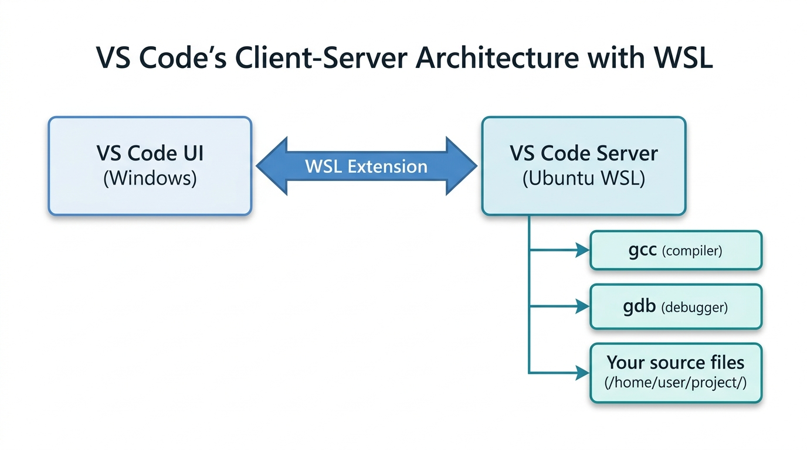

Step 1 — One-Time Setup

Windows Side
- Install VS Code (ensure "Add to PATH" is checked)
- Install the WSL extension (or the full Remote Development pack)

WSL Side
sudo apt-get update
sudo apt-get install build-essential gdb

Connect VS Code to WSL
- Open VS Code from Windows (Start Menu or desktop shortcut)
- Click the green remote icon in the bottom-left corner (or press Ctrl+Shift+P and search for "WSL: Connect to WSL")
- Select your Ubuntu distribution — VS Code will reload and install its server components inside WSL
- Go to File → Open Folder and navigate to your project path inside the Linux filesystem (e.g., /home/username/project/)
Important
Verify the bottom-left corner shows "WSL: Ubuntu" after connecting. All subsequent actions (extensions, terminal, debugging) will run inside the Linux environment.

Install Extensions in WSL
Open Extensions (Ctrl+Shift+X) and install C/C++ (by Microsoft). Look for the blue "Install in WSL: Ubuntu" button — this ensures the extension runs on the Linux side.

Step 2 — The Two JSON Files
When you press F5, VS Code executes a two-stage pipeline controlled by two files inside the .vscode/ folder of your project:
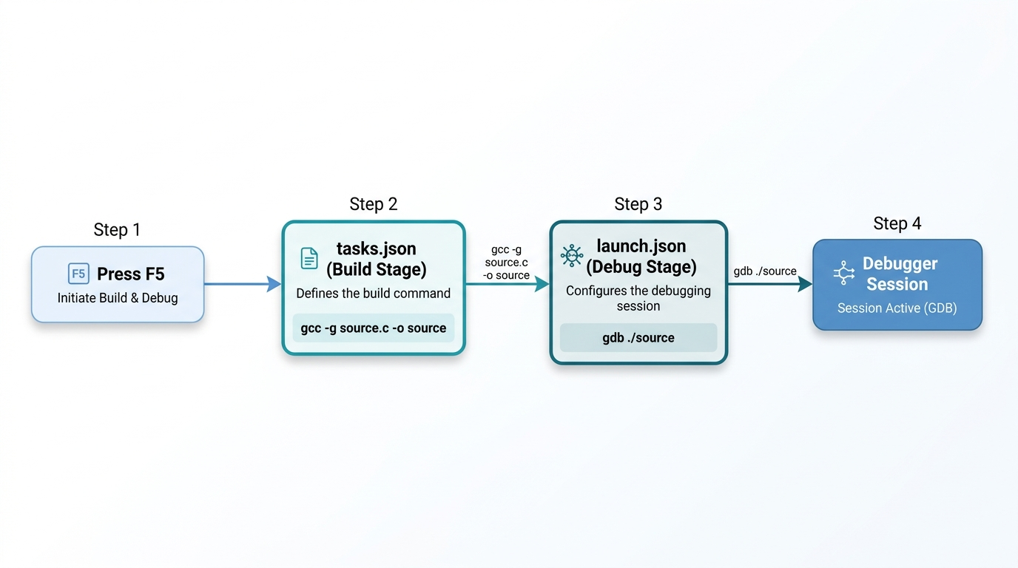

tasks.json — The Build Stage
This file tells VS Code how to compile your code. It runs before debugging because launch.json references it via preLaunchTask.
{
"version": "2.0.0",
"tasks": [
{
"type": "cppbuild",
"label": "C: gcc build active file",
"command": "/usr/bin/gcc",
"args": [
"-fdiagnostics-color=always",
"-g",
"${file}",
"-o",
"${fileDirname}/${fileBasenameNoExtension}"
],
"options": {
"cwd": "${workspaceFolder}"
},
"problemMatcher": ["$gcc"],
"group": {
"kind": "build",
"isDefault": true
},
"detail": "compiler: /usr/bin/gcc"
}
]
}
Field | Purpose
label | A name for this task — must exactly match the preLaunchTask in launch.json
command | The compiler to invoke (gcc for C, g++ for C++)
args | The flags passed to the compiler
-g | Critical — includes debug symbols so GDB can map machine code back to your source lines
${file} | Compiles whichever .c file you currently have open
-o .../${fileBasenameNoExtension} | Names the output executable after the source file (e.g., file.c → file)
problemMatcher | Parses gcc error output so VS Code can show errors inline in the editor
group.isDefault | Makes this the default build task, runnable via Ctrl+Shift+B
Tip
The resulting compiler invocation is equivalent to running this in the terminal:
gcc -fdiagnostics-color=always -g myfile.c -o myfile

launch.json — The Debug Stage
This file tells VS Code how to launch the debugger against your compiled executable.
{
"version": "0.2.0",
"configurations": [
{
"name": "Debug C file",
"type": "cppdbg",
"request": "launch",
"program": "${fileDirname}/${fileBasenameNoExtension}",
"args": [],
"stopAtEntry": false,
"cwd": "${workspaceFolder}",
"environment": [],
"externalConsole": false,
"MIMode": "gdb",
"miDebuggerPath": "/usr/bin/gdb",
"setupCommands": [
{
"description": "Enable pretty-printing for gdb",
"text": "-enable-pretty-printing",
"ignoreFailures": true
}
],
"preLaunchTask": "C: gcc build active file"
}
]
}
Field | Purpose
name | The label shown in the debug dropdown menu
type | cppdbg — uses the C/C++ extension's debugger adapter
request | launch starts a new process; the alternative attach connects to an already-running process
program | Path to the compiled executable (uses ${fileDirname}/${fileBasenameNoExtension} to match the build output)
args | Command-line arguments passed to your program (e.g., ["1024"] is like running ./myprogram 1024)
stopAtEntry | If true, pauses at main() automatically
cwd | Working directory for the running program
MIMode | The debugger backend — gdb or lldb
miDebuggerPath | Explicit path to the GDB binary inside WSL
setupCommands | GDB initialization commands (pretty-printing formats structs/arrays nicely)
preLaunchTask | The link between the two files — runs the matching task from tasks.json before debugging

Step 3 — The Debugging Workflow
Once both files are in place:
- Open any .c file in VS Code (connected to WSL)
- Set breakpoints by clicking the gutter (left margin) next to line numbers
- Press F5 — VS Code will:
  - Run the build task (e.g., gcc -g myfile.c -o myfile)
  - If compilation succeeds, launch GDB attached to the executable
  - Stop at your breakpoints
- Use the debug toolbar to:
  - Continue (F5) — run to next breakpoint
  - Step Over (F10) — execute current line, skip into functions
  - Step Into (F11) — enter the function being called
  - Step Out (Shift+F11) — finish current function and return
- Inspect variables in the sidebar's Variables panel, or hover over them in the editor
- Use the Debug Console at the bottom to evaluate C expressions or run GDB commands

VS Code Variables Reference
Both JSON files use special ${...} variables that VS Code resolves at runtime:
Variable | Resolves To | Example
${workspaceFolder} | Root folder open in VS Code | /home/user/project
${file} | The currently open file | /home/user/project/myfile.c
${fileDirname} | Directory of the current file | /home/user/project
${fileBasenameNoExtension} | Filename without extension | myfile
Note
Using ${file} and ${fileBasenameNoExtension} makes the config generic — it compiles and debugs whichever file you have open. Using hardcoded names like myfile.c makes it specific to one file, which is simpler but less flexible.

Quick Troubleshooting
Problem | Fix
C++ (GDB/LLDB) option missing from debugger list | Install the C/C++ extension inside WSL, and have a .c/.cpp file open
"Could not find task..." | Ensure the label in tasks.json exactly matches preLaunchTask in launch.json
Breakpoints not hit / "No debug symbols" | Make sure you compile with the -g flag
GDB not found | Run sudo apt install gdb in WSL, verify with which gdb
Slow file I/O | Store your project in the Linux filesystem (/home/...) not Windows (/mnt/c/...)

